How to fix a common mistake in LSTM time series forecasting

Seyed Mousavi
·
Follow
7 min read
·
May 2, 2024
When using LSTM for time series forecasting, people tend to fall into a common trap. To explain it we need to review how regressors and forecasers work. This is how a forecasting algorithm deals with a time series:

Meanwhile, a regression problem looks like this:
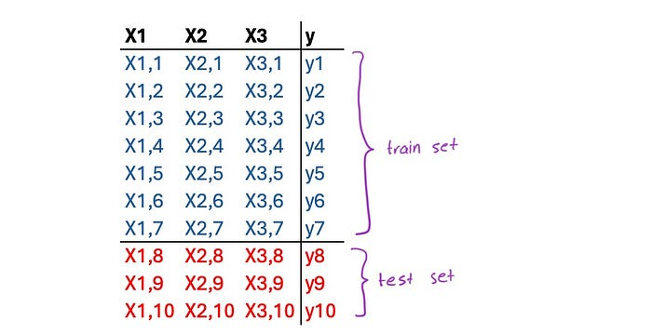
Because LSTM is a regressor, we need to transform our time series into a regression problem. There are numerous methods to do this, but in this section, we will discuss the Window and Multi-Step Methods, how they work, and particularly, how to avoid a common mistake in employing them.
In the Window Method, the time series is coupled with previous values of each time step as virtual features called the window. Here we have a window of size 3:
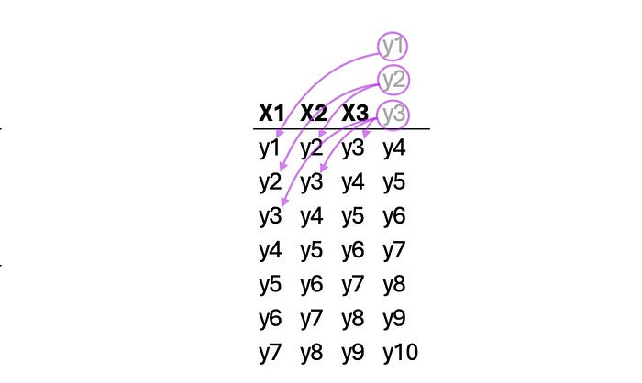
The following function creates a Window method data set from a single time series. The user should select the number of previous values (often called look back). The resulting data set will have diagonal repetition, and depending on the look-back value, the number of samples will vary:
def window(sequences, look_back):
X, y = [], []
for i in range(len(sequences)-look_back-1):
x = sequences[i:(i+look_back)]
X.append(x)
y.append(sequences[i + look_back])
return np.array(X), np.array(y)
Now, let’s examine the results. After the model is trained, it is tested over the test set. Multiple sources and tutorials proposed similar methods for compiling the results. However, as will be explained later, this method is not credible. But for now, let’s see what the code and results look like:
look_back = 3
X, y = window(ts_data, look_back)
# Train-test split
train_ratio = 0.8
train_size = int(train_ratio * len(ts_data))
X_train, X_test = X[:train_size-look_back], X[train_size-look_back:]
y_train, y_test = y[:train_size-look_back], y[train_size-look_back:]
# Create and train LSTM model
model = Sequential()
model.add(LSTM(units=72, activation='tanh', input_shape=(look_back, 1)))
model.add(Dense(1))
model.compile(loss='mean_squared_error', optimizer='Adam', metrics=['mape'])
model.fit(x=X_train, y=y_train, epochs=500, batch_size=18, verbose=2)
# Make predictions
forecasts = model.predict(X_test)
lstm_fits = model.predict(X_train)
# Calculate metrics
mape = mean_absolute_percentage_error(y_test, forecasts)
r2 = r2_score(y_train, lstm_fits)
# Initialize dates
date_range = pd.date_range(start='1990-01-01', end='2023-09-30', freq='M')
# Add empty values in fits to match the original time series
fits = np.full(train_size, np.nan)
for i in range(train_size-look_back):
fits[i+look_back] = lstm_fits[i]
# Plot actual, fits, and forecasts
plt.figure(figsize=(10, 6))
plt.plot(date_range, ts_data, label='Actual', color='blue')
plt.plot(date_range[:train_size], fits, label='Fitted', color='green')
plt.plot(date_range[train_size:], forecasts, label='Forecast', color='red')
plt.title('FSC - Short - Passengers\nOne Step Forward Forecast')
plt.xlabel('Date')
plt.ylabel('Passengers')
plt.legend()
plt.text(0.05, 0.05, f'R2 = {r2*100:.2f}%\nMAPE = {mape*100:.2f}%', transform=plt.gca().transAxes, fontsize=12)
plt.grid(True)
plt.show()
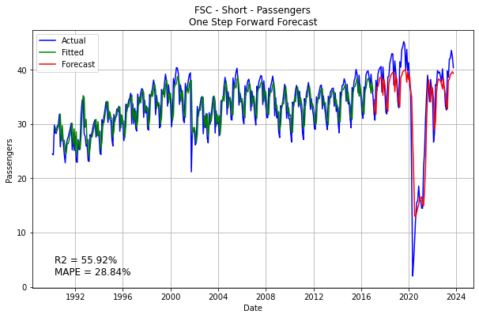
The Issue: Results look great. But taking a look at the sample test set, we see a peculiar flaw:
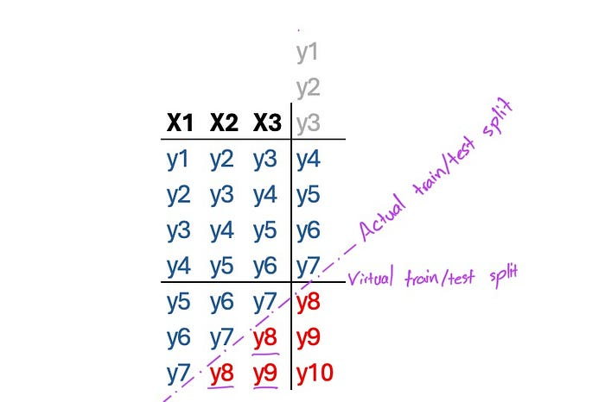
In producing y9 for example, y8 has been used in the model as input. Although it’s not used for training, incorporating future values is odd, considering we are forecasting timesteps of the future.
Resolution: An iterative test set that replaces input values with predicted values of the previous instance will solve the issue. In this arrangement, the model builds on its own predictions, just like a conventional forecasting algorithm:
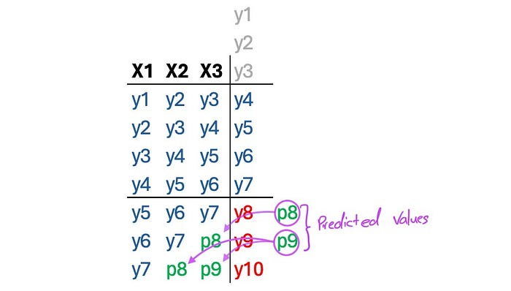
The following loop does this:
# Iterative prediction and substitution
for i in range(len(X_test)):
forecasts[i] = model.predict(X_test[i].reshape(1, look_back, 1))
if i != len(X_test)-1:
X_test[i+1,look_back-1] = forecasts[i]
for j in range(look_back-1):
X_test[i+1,j] = X_test[i,j+1]
The results are not as solid, but at least they are authentic:
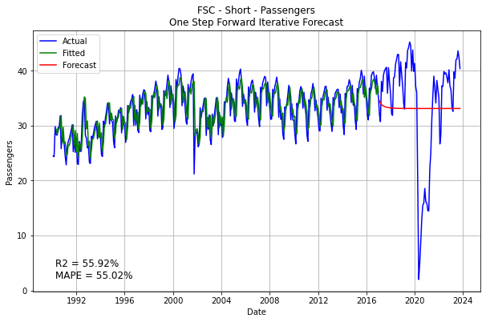
The Multi-Step Method is similar to the window method but has more target steps. Here is a sample of two forward steps:
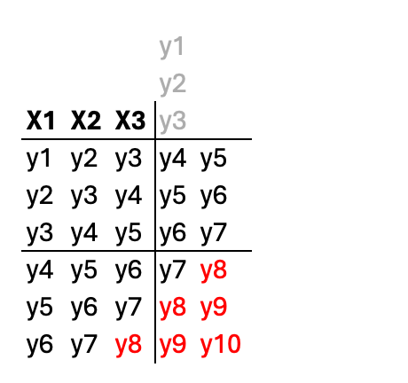
In fact, for this method, the user must select n_steps_in and n_steps_out. The following code transforms a simple time series into a data set ready for multi-step LSTM training:
# split a univariate sequence into samples with multi-steps
def split_sequences(sequences, n_steps_in, n_steps_out):
X, y = list(), list()
for i in range(len(sequences)):
# find the end of this pattern
end_ix = i + n_steps_in
out_end_ix = end_ix + n_steps_out
# check if we are beyond the sequence
if out_end_ix > len(sequences):
break
# gather input and output parts of the pattern
seq_x, seq_y = sequences[i:end_ix], sequences[end_ix:out_end_ix]
X.append(seq_x)
y.append(seq_y)
return np.array(X), np.array(y)
Now, not only the features but also the targets have diagonal repetitions, meaning that to compare with the time series, we either have to average them or select one of the predictions. In the codes below, the results of the first, last, and mean predictions are produced, followed by its plot. It should be noted that the first prediction here means one month in advance prediction, and the last prediction means 12 months in advance prediction.
n_steps_in = 12
n_steps_out = 12
X, y = split_sequences(ts_data, n_steps_in, n_steps_out)
X = X.reshape(X.shape[0], X.shape[1], 1)
y = y.reshape(y.shape[0], y.shape[1], 1)
# Train-test split
train_ratio = 0.8
train_size = int(train_ratio * len(ts_data))
X_train, X_test = X[:train_size-n_steps_in-n_steps_out+1], X[train_size-n_steps_in-n_steps_out+1:]
y_train = y[:train_size-n_steps_in-n_steps_out+1]
y_test = ts_data[train_size:]
# Create and train LSTM model
model = Sequential()
model.add(LSTM(units=72, activation='tanh', input_shape=(n_steps_in, 1)))
model.add(Dense(units=n_steps_out))
model.compile(loss='mean_squared_error', optimizer='Adam', metrics=['mape'])
model.fit(x=X_train, y=y_train, epochs=500, batch_size=18, verbose=2)
# Make predictions
lstm_predictions = model.predict(X_test)
lstm_fitted = model.predict(X_train)
forecasts = [np.diag(np.fliplr(lstm_predictions), i).mean() for i in range(0, -lstm_predictions.shape[0], -1)]
fits = [np.diag(np.fliplr(lstm_fitted), i).mean() for i in range(lstm_fitted.shape[1]+n_steps_in - 1, -lstm_fitted.shape[0], -1)]
forecasts1 = lstm_predictions[n_steps_out-1:,0]
fits1 = model.predict(X)[:train_size-n_steps_in,0]
forecasts12 = lstm_predictions[:,n_steps_out-1]
fits12 = lstm_fitted[:,n_steps_out-1]
# Metrics
av_mape = mean_absolute_percentage_error(y_test, forecasts)
av_r2 = r2_score(ts_data[n_steps_in:train_size], fits[n_steps_in:])
one_mape = mean_absolute_percentage_error(y_test[:-n_steps_out+1], forecasts1)
one_r2 = r2_score(ts_data[n_steps_in:train_size], fits1)
twelve_mape = mean_absolute_percentage_error(y_test, forecasts12)
twelve_r2 = r2_score(ts_data[n_steps_in+n_steps_out-1:train_size], fits12)

date_range = pd.date_range(start='1990-01-01', end='2023-09-30', freq='M')
# Plot actual, fits, and forecasts
plt.figure(figsize=(10, 6))
plt.plot(date_range, ts_data, label='Actual', color='blue')
plt.plot(date_range[:train_size], fits, label='Fitted', color='green')
plt.plot(date_range[train_size:], forecasts, label='Forecast', color='red')
plt.title('FSC - Short - Passengers\n. LSTM 12 Month Average Forecast')
plt.xlabel('Date')
plt.ylabel('Passengers')
plt.legend()
plt.text(0.05, 0.05, f'R2 = {av_r2*100:.2f}%\nMAPE = {av_mape*100:.2f}%', transform=plt.gca().transAxes, fontsize=12)
plt.grid(True)
plt.show()
plt.figure(figsize=(10, 6))
plt.plot(date_range, ts_data, label='Actual', color='blue')
plt.plot(date_range[n_steps_in:train_size], fits1, label='Fitted', color='green')
plt.plot(date_range[train_size:-n_steps_out+1], forecasts1, label='Forecast', color='red')
plt.title('FSC - Short - Passengers\n LSTM 1 Month in advance Forecast')
plt.xlabel('Date')
plt.ylabel('Passengers')
plt.legend()
plt.text(0.05, 0.05, f'R2 = {one_r2*100:.2f}%\nMAPE = {one_mape*100:.2f}%', transform=plt.gca().transAxes, fontsize=12)
plt.grid(True)
plt.show()
plt.figure(figsize=(10, 6))
plt.plot(date_range, ts_data, label='Actual', color='blue')
plt.plot(date_range[n_steps_in+n_steps_out-1:train_size], fits12, label='Fitted', color='green')
plt.plot(date_range[train_size:], forecasts12, label='Forecast', color='red')
plt.title('FSC - Short - Passengers\n LSTM 12 Months in advance Forecast')
plt.xlabel('Date')
plt.ylabel('Passengers')
plt.legend()
plt.text(0.05, 0.05, f'R2 = {twelve_r2*100:.2f}%\nMAPE = {twelve_mape*100:.2f}%', transform=plt.gca().transAxes, fontsize=12)
plt.grid(True)
plt.show()
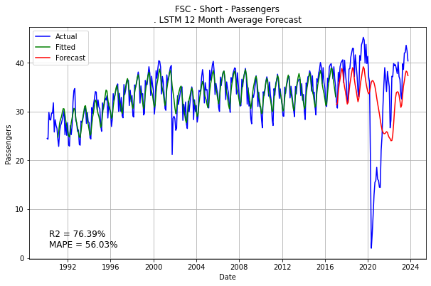
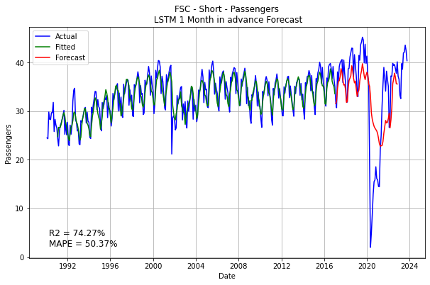
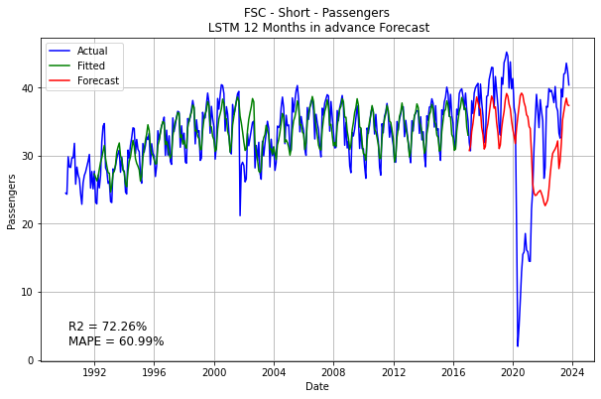
The Issue: The same issue with the Window Method persists here:
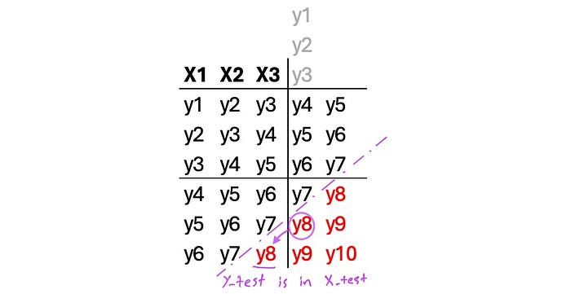
Resolution: We can employ a similar approach as we did in the Window Method. But we can also go another direction and choose the n_steps_out to be the same as the test_size. This way, the test set shrinks to only one:
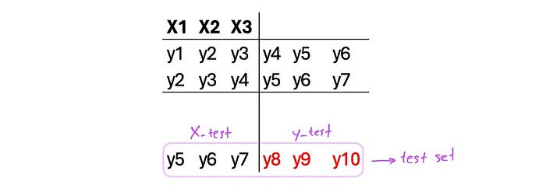
The function that follows does precisely this. It takes the time series, train size, and number of samples. I’ve named it comparable because this version can actually be compared to other forecasting algorithms:
def split_sequences_comparable(sequences, n_samples, train_size):
# Steps
n_steps_out = len(sequences) - train_size
n_steps_in = train_size - n_steps_out - n_samples + 1
# End sets
X_test = sequences[n_samples + n_steps_out - 1:train_size]
X_forecast = sequences[-n_steps_in:]
X, y = list(), list()
for i in range(n_samples):
# find the end of this pattern
end_ix = i + n_steps_in
out_end_ix = end_ix + n_steps_out
# gather input and output parts of the pattern
seq_x, seq_y = sequences[i:end_ix], sequences[end_ix:out_end_ix]
X.append(seq_x)
y.append(seq_y)
return np.array(X), np.array(y), np.array(X_test), np.array(X_forecast), n_steps_in, n_steps_out
For this function, because the number of steps out is already fixed, I decided that the number of samples and train size are to be chosen by the user, and it will calculate the maximum possible steps in. Here’s an executed code and its results:
n_samples = 12
train_size = 321
X_train, y_train, X_test, X_forecast, n_steps_in, n_steps_out = split_sequences_comparable(ts_data, n_samples, train_size)
y_test = ts_data[train_size:]
# Reshaping
X_train = X_train.reshape(X_train.shape[0], X_train.shape[1], 1)
X_test = X_test.reshape(X_test.shape[1], X_test.shape[0], 1)
y_train = y_train.reshape(y_train.shape[0], y_train.shape[1])
y_test = y_test.reshape(y_test.shape[1], y_test.shape[0], 1)
# Create and train LSTM model
model = Sequential()
model.add(LSTM(units=154, activation='tanh', input_shape=(n_steps_in, 1)))
model.add(Dense(units=n_steps_out))
model.compile(loss='mean_squared_error', optimizer='Adam', metrics=['mape'])
model.fit(x=X_train, y=y_train, epochs=500, batch_size=18, verbose=2)
# Make predictions
lstm_predictions = model.predict(X_test)
predictions = lstm_predictions.reshape(lstm_predictions.shape[1])
lstm_fitted = model.predict(X_train)
fits = [np.diag(np.fliplr(lstm_fitted), i).mean() for i in range(lstm_fitted.shape[1]+n_steps_in - 1, -lstm_fitted.shape[0], -1)]
# Metrics
mape = mean_absolute_percentage_error(y_test, predictions)
r2 = r2_score(ts_data[n_steps_in:train_size], fits[n_steps_in:])
# Plot actual, fits, and forecasts
plt.figure(figsize=(10, 6))
plt.plot(date_range, ts_data, label='Actual', color='blue')
plt.plot(date_range[:train_size], fits, label='Fitted', color='green')
plt.plot(date_range[train_size:], predictions, label='Forecast', color='red')
plt.title('FSC - Short - Passengers\n12 Sample Comparable LSTM Forecast')
plt.xlabel('Date')
plt.ylabel('Passengers')
plt.legend()
plt.text(0.05, 0.05, f'R2 = {r2*100:.2f}%\nMAPE = {mape*100:.2f}%\', transform=plt.gca().transAxes, fontsize=12)
plt.grid(True)
plt.show()
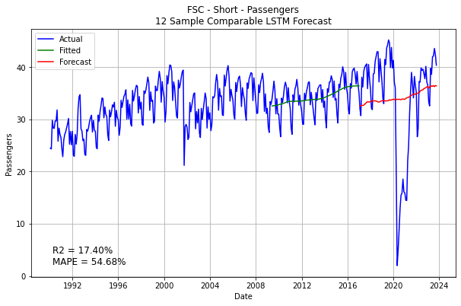
This is the best credible result we got so far. But we will have better results with a novel method I created. It will be discussed later in the series (Cyclic Method). First, we will explain how to tune the hyperparameters of an LSTM network.
It is worth mentioning that since LSTM aggregates all time steps into features, temporal data is lost in all these methods. We will use another method later in the series (Encoder/Decoder Method) that maintains the temporal structure of the input.
Stay tuned!

How to perform Hyperparameter Tuning for LSTM Time Series Forecasting
Seyed Mousavi
·
Follow
5 min read
·
May 16, 2024
This article follows the previous one about how time series data should be prepared for LSTM forecasting. All X, X_train, X_test, y, y_train and y_test sets are prepared according to that article. If you want to use the following codes, prepare your data according to that first. Please read it; it’s very important.

Grid Search
Although not supported by Keras and it is not usually meaningful and efficient, you can perform grid search parameter tuning for LSTM. Because of the nature of an LSTM network, its myriad configuration options, and the substantial amount of time it takes to learn, data scientists usually skip grid search hyperparameter tuning for LSTM. It will take a very long time depending on how big your parameter grid is, but in case you want to perform a grid search, the way to do it is by creating a model building function and then using Keras’ sklearn wrapper coupled with sklearn GridSearchCV:
from keras.wrappers.scikit_learn import KerasRegressor
from sklearn.model_selection import GridSearchCV
# Create LSTM function for sklearn grid search
def create_lstm_model(neurons=12, loss='mean_squared_error', activation='relu', optimizer='Adam', batch_size=12):
model = Sequential()
model.add(LSTM(units=neurons, activation=activation, input_shape=(n_steps_in, 1)))
model.add(Dense(units=n_steps_out))
model.compile(loss=loss, optimizer=optimizer, metrics=['mae'])

return model
# Wrap the custom wrapper function for use with scikit-learn
lstm_regressor = KerasRegressor(build_fn=create_lstm_model, epochs=50, batch_size=6, verbose=0)
# Define the parameter grid
param_grid = {
'optimizer': ['SGD', 'RMSprop', 'Adam'],
'loss': ['mean_squared_error', 'mean_absolute_error', 'root_mean_squared_error', 'huber'],
'batch_size': [6, 12, 18, 24],
'epochs': [100, 250, 500],
'neurons': [24, 36, 72],
'activation': ['relu', 'tanh', 'sigmoid', 'linear', 'swish']}
# Create the GridSearchCV object
grid_search = GridSearchCV(estimator=lstm_regressor, param_grid=param_grid, scoring='neg_mean_squared_error', cv=3)
# Fit the grid search to the data
grid_search_result = grid_search.fit(X, y)
Data should have been prepared for the grid search beforehand; n_steps_in and n_steps_out are related to how data was prepared; read this for more information. Also, remember that you don’t need to keep a holdout for grid search; it has an internal cross-validation function, so feed all your data in.
Now, this was a single-layered network. You often want to create a more sophisticated network with multiple layers. Or you might want to see if it’s a good idea to have multiple layers or not. You add another hyperparameter to the grid that defines the number of neurons of the second layer and then incorporate this into the model-building function so that if the number of neurons is zero, no second layer is created.
param_grid = {
'optimizer': ['SGD', 'RMSprop', 'Adam'],
'loss': ['mean_squared_error', 'mean_absolute_error', 'root_mean_squared_error', 'huber'],
'batch_size': [6, 12, 18, 24],
'epochs': [100, 250, 500],
'neurons': [24, 36, 72],
'second_layer':[0, 12, 24], # 0 means no second LSTM layer
'activation': ['relu', 'tanh', 'sigmoid', 'linear', 'swish']
}
# Create a double-layered LSTM function for sklearn grid search
def create_lstm_model(neurons=36, second_layer=12, loss='mean_absolute_error', activation='relu', optimizer='Adam', batch_size=12):
model = Sequential()
model.add(LSTM(units=neurons, activation=activation, input_shape=(n_steps_in, 1)))

if second_layer > 0:
model.add(LSTM(units=second_layer, return_sequences=False))

model.add(Dense(units=n_steps_out))
model.compile(loss=loss, optimizer=optimizer, metrics=['mae'])

return model
This is usually not very practical, as it is computationally very expensive, but I’m doing it for the rare occasions where it makes sense. You should probably downsize or adjust the grid based on your needs. You can also add a third layer or more using the same principle.

Early Stopping
The other useful feature of the Keras LSTM module is its EarlyStopping callback. EarlyStopping allows you to specify the conditions under which training is stopped prematurely. This will speed up the training process by eliminating unnecessary epochs:
early_stopper = EarlyStopping(monitor='loss', min_delta=0.01, patience=5)
The three arguments in the above are:
- monitor: The metric to be monitored, e.g., ‘loss’, ‘val_loss’, ‘accuracy’, etc.
- min_delta: The minimum change in the monitored metric to qualify as an improvement, i.e., an absolute change less than min_delta will count as no improvement.
- patience: The number of epochs with no improvement, after which training will be stopped.
‘EarlyStopping’ is passed to the fit() method via the model.fit() call.
model.fit(x=X_train, y=y_train, epochs=500, batch_size=18, callbacks=[early_stopper], verbose=2)
The same thing can be applied to the grid search, and by doing so, the search duration can be decreased significantly:
grid_search.fit(X, y, callbacks=[early_stopper])
You can keep only the biggest epochs size to benefit the most from the time-saving effect of the EarlyStopping callback.
param_grid = {
'optimizer': ['SGD', 'RMSprop', 'Adam'],
'loss': ['mean_squared_error', 'mean_absolute_error', 'root_mean_squared_error', 'huber'],
'batch_size': [6, 12, 18, 24],
'epochs': [500], # It runs 500 epochs unless stopped by EarlyStopping
'neurons': [24, 36, 72],
'second_layer':[0, 12, 24],
'activation': ['relu', 'tanh', 'sigmoid', 'linear', 'swish']
}

Keras Tuner
The other approach is to use KerasTuner, a hyperparameter optimisation framework within Keras, where options for hyperparameters “hp” are specified and passed to the model:
But first, you need to install it:
pip install --upgrade keras-tuner
conda install -c conda-forge keras-tuner
from keras_tuner import RandomSearch, Hyperband, BayesianOptimization
from keras_tuner.engine.hyperparameters import HyperParameters
# Create LSTM function for sklearn grid search
def create_lstm_model(hp):
model = Sequential()
model.add(LSTM(units=hp.Int('units', min_value=32, max_value=256, step=32),
activation=hp.Choice('activation', values=['relu', 'tanh', 'sigmoid']),
input_shape=(n_steps_in, n_features),
return_sequences=False))
for i in range(hp.Int('n_layers', 1, 3)):
model.add(LSTM(units=hp.Int(f'lstm_{i}_units', min_value=32, max_value=256, step=32),
return_sequences=False))

model.add(Dense(units=n_steps_out))
model.compile(loss=hp.Choice('loss', values=['mean_squared_error', 'mean_absolute_error']),
optimizer=hp.Choice('optimizer', values=['SGD', 'RMSprop', 'Adam']),
metrics=['mae'])
return model
# Create the tuner
tuner = RandomSearch( # You can research and experiment with Hyperband and BayesianOptimization
create_lstm_model,
objective='val_loss',
max_trials=10, # Adjust this depending on the computational resources
executions_per_trial=2, # Average the results of 2 runs to reduce variance
)
# EarlyStopping callback
early_stopper = EarlyStopping(monitor='val_loss', min_delta=0.01, patience=5, , restore_best_weights=True)
# Run the search
tuner.search(
X_train,
y_train,
epochs=500,
batch_size=12,
validation_data=(X_test, y_test),
callbacks=[early_stopper]
)
# Get the best model and hyperparameters
best_model = tuner.get_best_models(num_models=1)[0]
best_hyperparameters = tuner.get_best_hyperparameters(num_trials=1)[0]
print("Best hyperparameters: ", best_hyperparameters.values)
best_model.summary()
# Evaluate the best model on the validation set
val_loss, val_mae = best_model.evaluate(X_test, y_test)
print(f'Validation Loss: {val_loss}, Validation MAE: {val_mae}')
# Save the results
tuner_result = tuner.results_summary()
This code creates multiple LSTM networks of 1 to 3 layers, randomly searches through them, finds the best one, and presents its hyperparameters.

Evaluating Top Parameters
After performing a grid search, consider evaluating the best performers and the time each has taken. Sometimes, going with the second-best or third-best model is more advisable because they’re faster. You might get a model with 1% more error but with half of the fitting time. The following code takes the top 10 models and compiles them with their fitting time:
# Evaluate top10 parameter sets
results_df = pd.DataFrame(grid_search_result.cv_results_)
top_params = results_df.nlargest(10, 'mean_test_score')[['params', 'mean_test_score', 'mean_fit_time']]
This article is part of a series about using LSTM for time series forecasting; we explained how to tune the hyperparameters of an LSTM network. Next, we will explore ways to keep the temporal data in the time series while building the network. And then, in the final article, a novel method is presented, and it will be shown how it’s the best method to deal with seasonal data.
Stay tuned!

ARIMA-GARCH forecasting with Python


Thomas Dierckx
·
Follow
Published in
Analytics Vidhya
·
3 min read
·
Sep 9, 2020
163
5
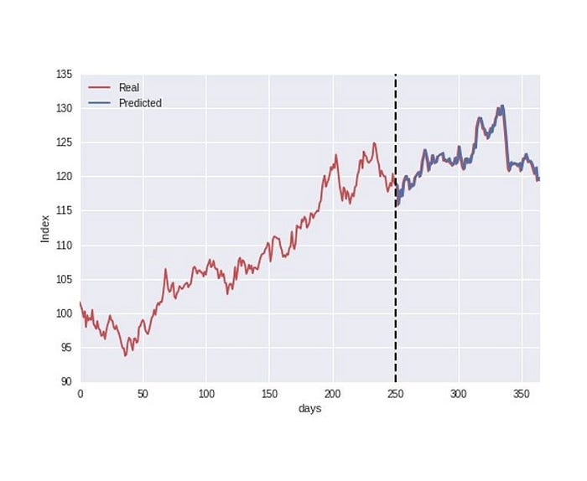
ARIMA models are popular forecasting methods with lots of applications in the domain of finance. For example, using a linear combination of past returns and residuals, an attempt can be made to predict future returns. Sadly, when returns exhibit a change in variance over time, this family of models runs into problems. This phenomenon is often present and also known as conditional variance, or volatility clustering. Luckily though, there’s another family of models able to model this irregularity: (G)ARCH models. Both types of models are therefore combined in practice to optimize forecasting performance.
Python has great packages for training both ARIMA and GARCH models separately, but none that actually combine both (like R’s nifty package rugarch — damn you R users). Let’s take a look at how we can combine these models in Python while staying clear of too much theory. There’s plenty of other tutorials out there to expand on what we cover in this post, and I’ll conveniently provide you with links when necessary. Let’s delve into it!

ARIMA modelling in Python
Python has two popular packages for modelling ARIMA processes: pmdarima and the statsmodels package. The great thing about pmdarima is that it finds the optimal ARIMA(p, d, q) parameters for you, whereas the statsmodels package forces you to manually find the optimal parameters. Both packages provide plenty of variables to tinker with, so their documentation is definitely worth a visit. In addition, there’s two great tutorials that cover ARIMA in Python more in depth: a statsmodels version and a pmdarima version.
pmdarima vs statsmodels

GARCH modelling in Python
When it comes to modelling conditional variance, arch is the Python package that sticks out. A more in depth tutorial can be found here. Note that there’s no package like pmdarima that automatically finds the optimal parameters p and q based on a given criterion.
Can a GARCH model be used on its own to predict returns? Yes and no. The model in the code snippet above assumes that returns have a constant mean. However, in real life, this won’t completely capture the skewness and leptokurtosis that is present. That’s why ARIMA and GARCH models are so often combined. An ARIMA model estimates the conditional mean, where subsequently a GARCH model estimates the conditional variance present in the residuals of the ARIMA estimation.

Combining ARIMA and GARCH
So how do we combine both ARIMA and GARCH models? Let’s have a brief look at the math behind an ARMA-GARCH model:
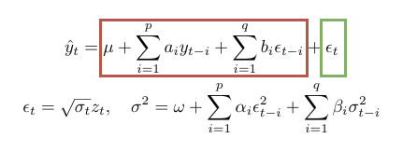
ARMA-GARCH model
The formula is pretty straightforward. The final prediction is given by combining the output of the ARIMA model (red) and GARCH model (green).
Let’s see how this works in Python! Note that we fit the GARCH model on the residuals of the ARIMA model instead of the returns this time.
That’s all there is to it! However, there’s one caveat in the way we work here (taken from a stackoverflow post):
You may choose to fit an ARMA model first and then fit a GARCH model on the ARMA residuals, but this is not the preferred way. Your ARMA estimates will generally be inconsistent. (In a special case where there are only AR terms and no MA terms, the estimates will be consistent but inefficient.) This will also contaminate the GARCH estimates. Therefore the preferred way is to estimate both ARMA and GARCH models simultaneously. Statistical software is capable of doing that (see e.g. rugarch package for R).
One way to overcome this problem is to train a lot of different ARIMA(p1, d, q1)-GARCH(p2, q2) models, and select the best working one based on criteria such as aic or bic.

Next steps
There’s an abundance of potential next steps to explore. For example, we used ARIMA to model the mean of the returns series. But other mean models exist. The same applies to variance modelling, as there’s plenty of other variance models to choose from! Lastly, we only considered the univariate case in this post. Here’s an excellent post how to apply ARIMA-GARCH on a multivariate case (in R).

